Barry Primary School
Barry Road, Northampton, NN1 5JS
Telephone : 01604 234574
Email: schooloffice@barryprimary.org
www.barryprimary.com
Headteacher: Mrs C Gardner-Potter
Deputy Head: Miss N Barrie
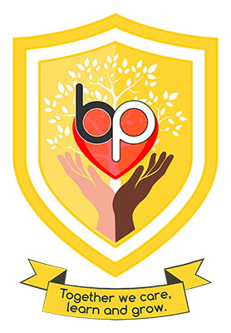
We are looking for hard working, committed individuals to join the
teaching support team in our early years setting.
Barry Primary is a large urban school that values inclusion and the development of a school community that is working together to provide the best for our children.

The successful candidate will:
- Have proven experience of working within a primary school and have at least NVQ Level 2 or good level of literacy and numeracy skills (GCSE or equivalent)
- Need to be flexible, resilient and able to work collaboratively to plan and support individual children and small groups
- Be hardworking and committed to ensure all children reach their full potential
- Work positively with staff, pupils and parents across our community

We can offer:
- A welcoming and inclusive school
- Lively, creative children, supportive governors and caring parents
- A hard-working, dedicated friendly team who are passionate about the teaching and achievement of all children
- A commitment to wellbeing, including a staff golden day

We are a popular two form entry school in the centre of Northampton, who again received a Good from Ofsted in June 2023. Our early years setting incorporates a large Nursery unit which cares for children aged 3 and up.
“The learning environment is purposeful and inviting. It is a place where children thrive,” (Ofsted. June 2023)
- Post is 32.5 hours per week 8.30am – 3.30pm Monday – Friday
- Contract is temporary, initially until 31st August 2025
- Pay grade is NJC Grade D 3-4
The post is subject to suitable references and an enhanced DBS check. The School and Nursery are committed to safeguarding and promoting the welfare of children and expects all staff to share this commitment. We are an equal opportunities employer.
Candidates who are foreign nationals, or a UK national who has lived abroad must provide a Certificate of Good Conduct as part of the safer recruitment process.
Please apply using the application form attached and return to schooloffice@barryprimary.org. If you are interested in this role, please apply as soon as possible. We reserve the right to interview early for the right applicant.

